- Develop a web page that allows the user to enter details of the passenger (name, age, email, gender).Write a client side scripting code to validate the email, age and gender, where email should consists of the special symbol @and period (.), where age between 1 to 100 and gender is male or female.
<!DOCTYPE html>
<html lang="en">
<head>
<meta charset="UTF-8">
<title>Passenger Details</title>
<style>
.error {
color: red;
}
</style>
<script>
function validateForm() {
var name = document.getElementById("name").value;
var age = document.getElementById("age").value;
var email = document.getElementById("email").value;
var gender = document.querySelector('input[name="gender"]:checked');

var errorMessages = [];

if (name.trim() === "") {
errorMessages.push("Please enter a valid name");
}

if (age < 1 || age > 100 || isNaN(age)) {
errorMessages.push("Please enter a valid age between 1 and 100");
}

if (!validateEmail(email)) {
errorMessages.push("Please enter a valid email address");
}

if (!gender) {
errorMessages.push("Please select a gender");
}

if (errorMessages.length > 0) {
var errorContainer = document.getElementById("error-container");
errorContainer.innerHTML = "";
errorMessages.forEach(function(message) {
var errorElement = document.createElement("p");
errorElement.classList.add("error");
errorElement.textContent = message;
errorContainer.appendChild(errorElement);
});
return false;
}

return true;
}

function validateEmail(email) {
var emailRegex = /^[^\s@]+@[^\s@]+\.[^\s@]+$/;
return emailRegex.test(email);
}
</script>
</head>
<body>
<h1>Passenger Details</h1>
<form onsubmit="return validateForm()">
<label for="name">Name:</label>
<input type="text" id="name" required><br>

<label for="age">Age:</label>
<input type="number" id="age" required><br>

<label for="email">Email:</label>
<input type="email" id="email" required><br>

<label for="gender">Gender:</label>
<input type="radio" id="male" name="gender" value="male" required>
<label for="male">Male</label>
<input type="radio" id="female" name="gender" value="female" required>
<label for="female">Female</label><br>

<input type="submit" value="Submit">
</form>

<div id="error-container"></div>
</body>
</html>

- Design a Passenger Registration form with First Name, Last name, Address, City, State, Country, Pincode, Username and Password fields for a General login webpage and satisfy the following criteria:
(a) Check that the First Name, Last Name, City, Country, Username, and Password fields are filled out.
(b) Check that the Pincode is exactly 6 numerics.
(c) Check that the state is exactly three characters.
(d) Check that the email is a valid email address.
<!DOCTYPE html>
<html lang="en">
<head>
<meta charset="UTF-8">
<title>Passenger Registration</title>
<style>
.error {
color: red;
}
</style>
<script>
function validateForm() {
var firstName = document.getElementById("first-name").value;
var lastName = document.getElementById("last-name").value;
var city = document.getElementById("city").value;
var country = document.getElementById("country").value;
var pincode = document.getElementById("pincode").value;
var state = document.getElementById("state").value;
var username = document.getElementById("username").value;
var password = document.getElementById("password").value;
var email = document.getElementById("email").value;

var errorMessages = [];

if (firstName.trim() === "") {
errorMessages.push("Please enter your First Name");
}

if (lastName.trim() === "") {
errorMessages.push("Please enter your Last Name");
}

if (city.trim() === "") {
errorMessages.push("Please enter your City");
}

if (country.trim() === "") {
errorMessages.push("Please enter your Country");
}

if (username.trim() === "") {
errorMessages.push("Please enter a Username");
}

if (password.trim() === "") {
errorMessages.push("Please enter a Password");
}

if (pincode.trim() === "" || !/^\d{6}$/.test(pincode)) {
errorMessages.push("Please enter a valid 6-digit Pincode");
}

if (state.trim() === "" || state.length !== 3) {
errorMessages.push("Please enter a valid 3-character State");
}

if (email.trim() === "" || !validateEmail(email)) {
errorMessages.push("Please enter a valid email address");
}

if (errorMessages.length > 0) {
var errorContainer = document.getElementById("error-container");
errorContainer.innerHTML = "";
errorMessages.forEach(function(message) {
var errorElement = document.createElement("p");
errorElement.classList.add("error");
errorElement.textContent = message;
errorContainer.appendChild(errorElement);
});
return false;
}

return true;
}

function validateEmail(email) {
var emailRegex = /^[^\s@]+@[^\s@]+\.[^\s@]+$/;
return emailRegex.test(email);
}
</script>
</head>
<body>
<h1>Passenger Registration</h1>
<form onsubmit="return validateForm()">
<label for="first-name">First Name:</label>
<input type="text" id="first-name" required><br>

<label for="last-name">Last Name:</label>
<input type="text" id="last-name" required><br>

<label for="address">Address:</label>
<input type="text" id="address"><br>

<label for="city">City:</label>
<input type="text" id="city" required><br>

<label for="state">State:</label>
<input type="text" id="state" maxlength="3" required><br>

<label for="country">Country:</label>
<input type="text" id="country" required><br>

<label for="pincode">Pincode:</label>
<input type="text" id="pincode" pattern="\d{6}" required><br>

<label for="username">Username:</label>
<input type="text" id="username" required><br>

<label for="password">Password:</label>
<input type="password" id="password" required><br>

<label for="email">Email:</label>
<input type="email" id="email" required><br>

<input type="submit" value="Register">
</form>

<div id="error-container"></div>
</body>
</html>

- Create an online-examination web portal. Prepare the questions of your choice. The students should enter their name and register number before answering the questions. The online exam should contain at least five questions of type multiple choice. The choice of selection should use radio buttons and for each correct answer one mark should be awarded. After attempting all questions, proceed with submit button. After clicking the submit button, display the result with register number, name of the student and marks. Design a web portal using JavaScript and HTML forms.

<!DOCTYPE html>
<html lang="en">
<head>
<meta charset="UTF-8">
<title>Online Examination</title>
<style>
.question {
margin-bottom: 10px;
}
</style>
</head>
<body>
<h1>Online Examination</h1>
<form id="exam-form">
<label for="name">Name:</label>
<input type="text" id="name" required><br>

<label for="register-number">Register Number:</label>
<input type="text" id="register-number" required><br>

<div class="question">
<p>1. What is the capital of France?</p>
<input type="radio" name="q1" value="a" required> a) Paris<br>
<input type="radio" name="q1" value="b"> b) Rome<br>
<input type="radio" name="q1" value="c"> c) Madrid<br>
</div>

<div class="question">
<p>2. Which planet is known as the Red Planet?</p>
<input type="radio" name="q2" value="a" required> a) Mars<br>
<input type="radio" name="q2" value="b"> b) Venus<br>
<input type="radio" name="q2" value="c"> c) Jupiter<br>
</div>

<div class="question">
<p>3. Who painted the Mona Lisa?</p>
<input type="radio" name="q3" value="a" required> a) Leonardo da Vinci<br>
<input type="radio" name="q3" value="b"> b) Vincent van Gogh<br>
<input type="radio" name="q3" value="c"> c) Pablo Picasso<br>
</div>

<div class="question">
<p>4. What is the chemical symbol for gold?</p>
<input type="radio" name="q4" value="a" required> a) Au<br>
<input type="radio" name="q4" value="b"> b) Ag<br>
<input type="radio" name="q4" value="c"> c) Pt<br>
</div>

<div class="question">
<p>5. Who wrote the play "Hamlet"?</p>
<input type="radio" name="q5" value="a" required> a) William Shakespeare<br>
<input type="radio" name="q5" value="b"> b) Oscar Wilde<br>
<input type="radio" name="q5" value="c"> c) George Bernard Shaw<br>
</div>

<input type="submit" value="Submit">
</form>

<div id="result-container" style="display: none;">
<h2>Result</h2>
<p id="student-info"></p>
<p id="marks"></p>
</div>

<script>
document.getElementById('exam-form').addEventListener('submit', function(event) {
event.preventDefault();

var name = document.getElementById('name').value;
var registerNumber = document.getElementById('register-number').value;
var marks = 0;

if (document.querySelector('input[name="q1"]:checked').value === 'a') {
marks++;
}
if (document.querySelector('input[name="q2"]:checked').value === 'a') {
marks++;
}
if (document.querySelector('input[name="q3"]:checked').value === 'a') {
marks++;
}
if (document.querySelector('input[name="q4"]:checked').value === 'a') {
marks++;
}
if (document.querySelector('input[name="q5"]:checked').value === 'a') {
marks++;
}

document.getElementById('student-info').textContent = 'Name: ' + name + ', Register Number: ' + registerNumber;
document.getElementById('marks').textContent = 'Marks Obtained: ' + marks;

document.getElementById('exam-form').style.display = 'none';
document.getElementById('result-container').style.display = 'block';
});
</script>
</body>
</html>

- Design a web page with the text box where the user can enter a four digit number with a validation button. The digits entered here must be in ascending order for the input (eg. 1234, 5678). Validate the field using JavaScript.
<!DOCTYPE html>
<html lang="en">
<head>
<meta charset="UTF-8">
<title>Ascending Order Validation</title>
</head>
<body>
<h1>Ascending Order Validation</h1>
<label for="number-input">Enter a four-digit number:</label>
<input type="text" id="number-input">
<button onclick="validateAscendingOrder()">Validate</button>

<script>
function validateAscendingOrder() {
var numberInput = document.getElementById('number-input').value;

// Check if the input has four digits
if (numberInput.length !== 4) {
alert('Please enter a four-digit number.');
return;
}

// Check if the digits are in ascending order
if (
parseInt(numberInput[0]) <= parseInt(numberInput[1]) &&
parseInt(numberInput[1]) <= parseInt(numberInput[2]) &&
parseInt(numberInput[2]) <= parseInt(numberInput[3])
) {
alert('The digits are in ascending order.');
} else {
alert('The digits are not in ascending order.');
}
}
</script>
</body>
</html>

- Design a JavaScript program to display a message “Hi good morning to you” when a page is loaded and displays a message “Thanks for visiting our web page” when a page is unloaded.

<!DOCTYPE html>
<html lang="en">
<head>
<meta charset="UTF-8">
<title>Page Load and Unload Events</title>
</head>
<body>
<h1>Page Load and Unload Events</h1>
<a href="https://www.google.com/">unload</a>
<script>
window.onload = function() {
// Display message when the page is loaded
alert('Hi, good morning to you!');
};

window.addEventListener('beforeunload', function(event) {
// Customize the confirmation message
event.preventDefault();
event.returnValue = 'Are you sure you want to leave this page?';
});
</script>
</body>
</html>

- Write JavaScript for the following. Provide a text box for the user to enter user name. Validate the user name must contain eight characters. Provide submit button for the validation to happen. On successful validation display a new page with an image and two textboxes for entering width and height of the image respectively with a resize button at the bottom of the image. On clicking the resize button validate the width and height on successful validation display the image.
<!DOCTYPE html>
<html lang="en">
<head>
<meta charset="UTF-8">
<title>Image Resize</title>
<script>
function validateResize() {
var width = document.getElementById('width').value;
var height = document.getElementById('height').value;
if (isNaN(width) || isNaN(height) || width <= 0 || height <= 0) {
alert('Width and height must be positive numbers.');
return false;
}
return true;
}

function resizeImage() {
if (validateResize()) {
var width = document.getElementById('width').value;
var height = document.getElementById('height').value;
var image = document.getElementById('image');
image.style.width = width + 'px';
image.style.height = height + 'px';
}
}
</script>
</head>
<body>
<h1>Image Resize</h1>

<img id="image" src="https://tse1.mm.bing.net/th?id=OIP.bRNjuCfhN2cKxplM7Fpr_AHaHa&pid=Api&P=0&h=180" alt="Image">

<form id="resizeForm" onsubmit="return false;">
<label for="width">Width:</label>
<input type="number" id="width" name="width" min="1" required>
<label for="height">Height:</label>
<input type="number" id="height" name="height" min="1" required>
<button onclick="resizeImage()">Resize</button>
</form>
</body>
</html>

- Design a JavaScript program to display a message “Hi good morning to you” when a page is loaded and displays a message “Thanks for visiting our web page” when a page is unloaded and capture script error using event handler.

- Design a myNotes logging application and implement the following concepts Using Morgan Middleware:
- handle POST submissions
- display customized error messages
- perform logging

- Design a myNotes logging application, include these below APIs based on the requirements provided.
- API should fetch the details of the notes based on a notesID which is provided in the URL.
Test URL - http://localhost:3000/notes/7555.

- Design a myNotes logging application, include these below APIs based on the requirements provided.
- API should update the details based on the name which is provided in the URL and the data in the request body.
Test URL - http://localhost:3000/notes/Mathan
Note: Only one document in the collection needs to be updated.

- Design a myNotes logging application, include these below APIs based on the requirements provided.
- API should delete the details based on the name which is provided in the URL.
Test URL - http://localhost:3000/notes/Mathan
Note: Only one document in the collection needs to be deleted
Note: Incorporate required security measures to implementation a secure application.

- Implement routing for the Adventure Trails application as per the below requirement. Write the necessary code in the routes/route.js file.
Sl. No. | Route path | Success response | Error response
1 | /packages | Status code: 200  A JSON object with property:  - message: "You can now get the requested packages for your request". | Status code: 404  A JSON object with property:  - status: "fail"  - message: the error message
2 | /bookpackage | Status code: 201  A JSON object with property:  - message: "New booking added for the POST request" | Status code: 404  A JSON object with property:  - status: "fail"  - message: the error message
3 | /all | - | Status code: 404  A JSON object with property:  - status: "fail"  - message: "invalid path"

- Create a file fileSystem.js and highlight the following procedures:
- Usage of fs.writeFile() method
- write' data to a file

const fs = require('fs');

const data = 'This is some data that we want to write to a file.';

fs.writeFile('example.txt', data, (err) => {
if (err) throw err;
console.log('Data written to file successfully.');
});

- The static file middleware does not specially treat hello.html as it did index.html, so you will have to access the application with the name of the file like this:
http://localhost:3000/hello.html.
const express = require('express');
const app = express();

// serve static files from the public directory
app.use(express.static('public'));

// start the server
app.listen(3000, () => {
console.log('Server started on port 3000');
});

- Raj needs an Expense tracker to keep track of his expenses. Build an Expense Tracker using React Hooks & Context API. The expense tracker allows Raj to add his expenses and to categorize them into Expenses on:
- Groceries
- Bill payments
- Education
- Entertainment
App.js
- import React, { useState, useContext } from 'react';

- // Step 1: Create an ExpenseContext
- const ExpenseContext = React.createContext();

- // Step 2: Create an ExpenseProvider component
- const ExpenseProvider = ({ children }) => {
- const [expenses, setExpenses] = useState([]);

- // Step 3: Define functions to add expenses and update the state
- const addExpense = (title, category) => {
- const newExpense = { title, category };
- setExpenses([...expenses, newExpense]);
- };

- // Step 4: Provide the context value to the children components
- return (
- <ExpenseContext.Provider value={{ expenses, addExpense }}>
- {children}
- </ExpenseContext.Provider>
- );
- };

- // Step 5: Create an ExpenseForm component to add expenses
- const ExpenseForm = () => {
- const { addExpense } = useContext(ExpenseContext);
- const [title, setTitle] = useState('');
- const [category, setCategory] = useState('');

- const handleSubmit = (e) => {
- e.preventDefault();
- addExpense(title, category);
- setTitle('');
- setCategory('');
- };

- return (
- <form onSubmit={handleSubmit}>
- <input
- type="text"
- placeholder="Expense title"
- value={title}
- onChange={(e) => setTitle(e.target.value)}
- />
- <select
- value={category}
- onChange={(e) => setCategory(e.target.value)}
- >
- <option value="">Select a category</option>
- <option value="Groceries">Groceries</option>
- <option value="Bill payments">Bill payments</option>
- <option value="Education">Education</option>
- <option value="Entertainment">Entertainment</option>
- </select>
- <button type="submit">Add Expense</button>
- </form>
- );
- };

- // Step 6: Create an ExpenseList component to display expenses
- const ExpenseList = () => {
- const { expenses } = useContext(ExpenseContext);

- return (
- <div>
- <h2>Expenses:</h2>
- <ul>
- {expenses.map((expense, index) => (
- <li key={index}>
- {expense.title} - {expense.category}
- </li>
- ))}
- </ul>
- </div>
- );
- };

- // Step 7: Create the App component
- const App = () => {
- return (
- <ExpenseProvider>
- <ExpenseForm />
- <ExpenseList />
- </ExpenseProvider>
- );
- };

- export default App;

- Neha is a person who likes to communicate through emojis. Implement a React app for searching emojis based on typed text.

- Naveen and Praveen want to spend their time by playing a two-player game. Build the Tic-Tac-Toe game in React to help them.

- Mohan is a film-freak. Build a movie search engine web application using React.js, which displays the top 10 Trending movies and links the selected movie in YouTube and help Mohan.

- SK Stores is a small Departmental Store near you. Build a small shopping cart web application using React, to serve the Store.

App.js

import React, { useState } from 'react';

function App() {
const [cartItems, setCartItems] = useState([]);

const addToCart = (item) => {
setCartItems([...cartItems, item]);
};

const removeFromCart = (item) => {
const updatedCartItems = cartItems.filter((cartItem) => cartItem.id !== item.id);
setCartItems(updatedCartItems);
};

return (
<div>
<h1>SK Stores - Shopping Cart</h1>
<h2>Products</h2>
<ul>
<li>
Product 1
<button onClick={() => addToCart({ id: 1, name: 'Product 1' })}>Add to Cart</button>
</li>
<li>
Product 2
<button onClick={() => addToCart({ id: 2, name: 'Product 2' })}>Add to Cart</button>
</li>
<li>
Product 3
<button onClick={() => addToCart({ id: 3, name: 'Product 3' })}>Add to Cart</button>
</li>
</ul>
<h2>Cart</h2>
{cartItems.length === 0 ? (
<p>Your cart is empty</p>
) : (
<ul>
{cartItems.map((item) => (
<li key={item.id}>
{item.name}
<button onClick={() => removeFromCart(item)}>Remove</button>
</li>
))}
</ul>
)}
</div>
);
}

export default App;

- Build a React Hooks app for calculating BMI of Kumar, who is a fitness freak. Kumar is allowed to enter his height and weight.
App.js
import React, { useState } from 'react';

function App() {
const [height, setHeight] = useState('');
const [weight, setWeight] = useState('');
const [bmi, setBmi] = useState(null);

const calculateBMI = () => {
if (height && weight) {
const heightInMeters = height / 100;
const bmiValue = weight / (heightInMeters * heightInMeters);
setBmi(bmiValue.toFixed(2));
} else {
setBmi(null);
}
};

return (
<div>
<h1>BMI Calculator</h1>
<label>
Height (in cm):
<input type="number" value={height} onChange={(e) => setHeight(e.target.value)} />
</label>
<br />
<label>
Weight (in kg):
<input type="number" value={weight} onChange={(e) => setWeight(e.target.value)} />
</label>
<br />
<button onClick={calculateBMI}>Calculate BMI</button>
{bmi && <p>Your BMI: {bmi}</p>}
</div>
);
}

export default App;

- Siva is a fresher buddy searching for a good job. Build a Resume Builder Web Application using React. Siva must be allowed to give the details. The resume must be built with appropriate phrases.

- Build a simple to-do app using React, having the feature to strikethrough to-do items/tasks that are completed. It must be used by Keerthy, a budding business guy. Keerthy must be allowed to enter the tasks every morning and as soon as the task is completed, he should tap on the completed task.

Keerthy.js

import React, { useState } from 'react';

const Keerthy = () => {
const [task, setTask] = useState('');
const [todos, setTodos] = useState([]);

const handleTaskChange = (e) => {
setTask(e.target.value);
};

const handleAddTask = () => {
if (task.trim() !== '') {
setTodos([...todos, { task, completed: false }]);
setTask('');
}
};

const handleToggleComplete = (index) => {
setTodos((prevTodos) => {
const updatedTodos = [...prevTodos];
updatedTodos[index].completed = !updatedTodos[index].completed;
return updatedTodos;
});
};

return (
<div>
<h1>Todo App</h1>
<input
type="text"
placeholder="Enter task"
value={task}
onChange={handleTaskChange}
/>
<button onClick={handleAddTask}>Add Task</button>
<ul>
{todos.map((todo, index) => (
<li
key={index}
style={{ textDecoration: todo.completed ? 'line-through' : 'none' }}
onClick={() => handleToggleComplete(index)}
>
{todo.task}
</li>
))}
</ul>
</div>
);
};

export default Keerthy;

App.js

import React from 'react';
import Keerthy from './component/Keerthy';

const App = () => {
return (
<div>
<h1>Keerthy Example</h1>
<Keerthy />
</div>
);
};

export default App;

- Build a weather application that provides the weather details for a location specified by the farmers of a particular district in Tamil Nadu.

WeatherApp.js

import React, { useState } from 'react';

const WeatherApp = () => {
const [location, setLocation] = useState('');
const [weatherData, setWeatherData] = useState(null);
const apiKey = 'YOUR_API_KEY'; // Replace with your actual API key

const handleLocationChange = (e) => {
setLocation(e.target.value);
};

const fetchWeatherData = async () => {
try {
const response = await fetch(
`https://api.openweathermap.org/data/2.5/weather?q=${location},Tamil Nadu,India&appid=${apiKey}`
);
const data = await response.json();
setWeatherData(data);
} catch (error) {
console.log('Error fetching weather data:', error);
}
};

return (
<div>
<h1>Weather App</h1>
<input
type="text"
placeholder="Enter location"
value={location}
onChange={handleLocationChange}
/>
<button onClick={fetchWeatherData}>Get Weather</button>
{weatherData && (
<div>
<h2>{weatherData.name}</h2>
<p>Temperature: {weatherData.main.temp}</p>
<p>Humidity: {weatherData.main.humidity}</p>
<p>Wind Speed: {weatherData.wind.speed}</p>
</div>
)}
</div>
);
};

export default WeatherApp;

App.js

import React from 'react';
import WeatherApp from './component/WeatherApp';

const App = () => {
return (
<div>
<h1>WeatherApp Example</h1>
<WeatherApp />
</div>
);
};

export default App;

- Write a functional component to render a button and a list of activities. The list of activities should start out with one activity. When the user clicks the button, an additional activity should be fetched and appended to the list. To generate a random activity, issue a get request to “https://www.boredapi.com/api/activity” — an API for development that does not require authentication. Each request will return a new, random object containing the following fields: activity, type, participants, price, link, key, and accessibility. The values associated with these fields are either strings or numbers. Here is an example of one such object:
{
"activity": "Take your dog on a walk",
"type": "relaxation",
"participants": 1,
"price": 0,
"link": "",
"key": "9318514",
"accessibility": 0.2
}
Each item in the list should display the activity and a button beside it that, when clicked, renders the remaining fields from that activity’s object below it. Here is an example of the final product, where the user has expanded the last activity in the list.
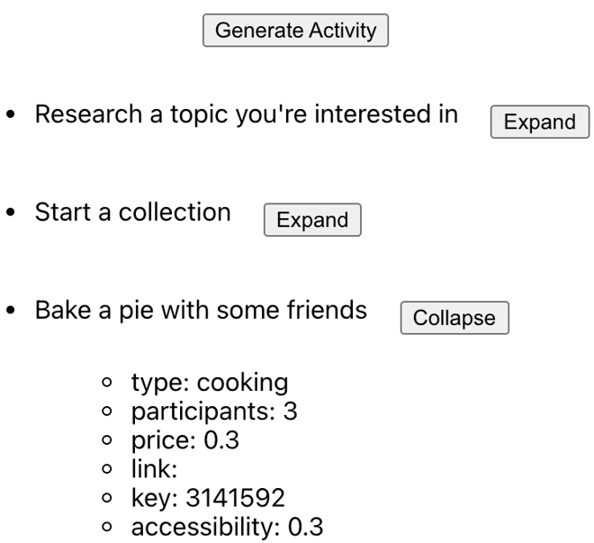

Functionality is most important, but feel free to style the page beyond the basic UI above. Your component should make use of the useEffect() hook. Also, feel free to break up the page’s functionality into subcomponents; in the solution provided below, I use a separate component for list items. Finally, pay close attention to how your application functions when the user repeatedly clicks the Generate Activity button. If your approach is similar to mine, you may run into an issue where list appends overwrite previous ones because they append to stale state.
Starter Code (App.js)
Use the environment you are most comfortable with. I recommend using create-react-app to create a local version of the project so that you can inspect easily from your browser when debugging. Alternatively, you can work from a blank React template in CodeSandbox.

ActivityList.js

import React, { useState, useEffect } from 'react';

const ActivityList = () => {
const [activities, setActivities] = useState([]);

const fetchActivity = async () => {
try {
const response = await fetch('https://www.boredapi.com/api/activity');
const data = await response.json();
setActivities((prevActivities) => [...prevActivities, data]);
} catch (error) {
console.error('Error fetching activity:', error);
}
};

useEffect(() => {
fetchActivity();
}, []);

const renderDetails = (activity) => {
const { type, participants, price, link, key, accessibility } = activity;
return (
<div>
<p>Type: {type}</p>
<p>Participants: {participants}</p>
<p>Price: {price}</p>
<p>Link: {link}</p>
<p>Key: {key}</p>
<p>Accessibility: {accessibility}</p>
</div>
);
};

return (
<div>
<h1>Activity List</h1>
<button onClick={fetchActivity}>Generate Activity</button>
<ul>
{activities.map((activity, index) => (
<li key={index}>
{activity.activity}
<button onClick={() => renderDetails(activity)}>Details</button>
{activity.expanded && renderDetails(activity)}
</li>
))}
</ul>
</div>
);
};

export default ActivityList;

App.js

import React from 'react';
import ActivityList from './component/ActivityList';

const App = () => {
return (
<div>
<h1>ActivityList Example</h1>
<ActivityList />
</div>
);
};

export default App;

- Create a functional component that renders an object of users extracted from context using React’s useContext() hook. The object’s keys are the users' names and the associated values are booleans that indicate whether the users are online or offline. The object should be defined in the parent component’s state and the object, as well as its associated setState() function, should be provided to the aforementioned functional component via context. Here is an example object initialized in state:
const [userState, setUserState] = useState({
Bob: true,
Gary: true,
Jessica: true,
Sam: true,
Eric: true,
});
Again, userState and setUserState() should be passed to the child of their enclosing component via context. The child should extract userState and setUserState() using the useContext() hook. It should display each user’s name alongside an icon indicating if the user is online or offline. Every two seconds, the component should change the status of a random user to the opposite of their current status.

Starter Code (App.js)
Use the environment you are most comfortable with. I recommend using create-react-app to create a local version of the project so that you can inspect easily from your browser when debugging. Alternatively, you can work from a blank React template in CodeSandbox.

- Create a functional component to render a list of tasks (along with their subtasks) from an object. The subtasks should be organized into two columns, completed and to be completed, based on the boolean value associated with each task. The object will have the following format: any number of keys where each key is the text of the task, an array of any number of objects associated with each key, and finally, an object with one field (the subtask text) and one associated boolean value at every index of the array. Here is an example of one such object:
const INITIAL_LIST = {
"Organize closet": [
{ "Donate old clothes and shoes": false },
{ "Buy new shelf": false },
{ "Put in shelf by color": false },
],
"Finish homework": [
{ "Finish math homework": false },
{ "Finish science homework": false },
{ "Finish Reactjs homework": false },
],
"Achieve nirvana": [
{ "Meditate a little": false },
{ "Gain some wisdom": false },
],
};
When the user clicks on an uncompleted subtask, it should move from the uncompleted list to the completed list. Likewise, when the user clicks on a completed subtask, it should move from the completed list to the uncompleted list. Here is the initial state of the page:
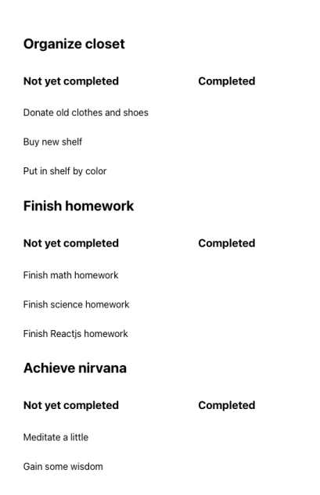
Here is the page after the user has clicked on the subtasks, “Donate old clothes and shoes” and “Finish math homework”.
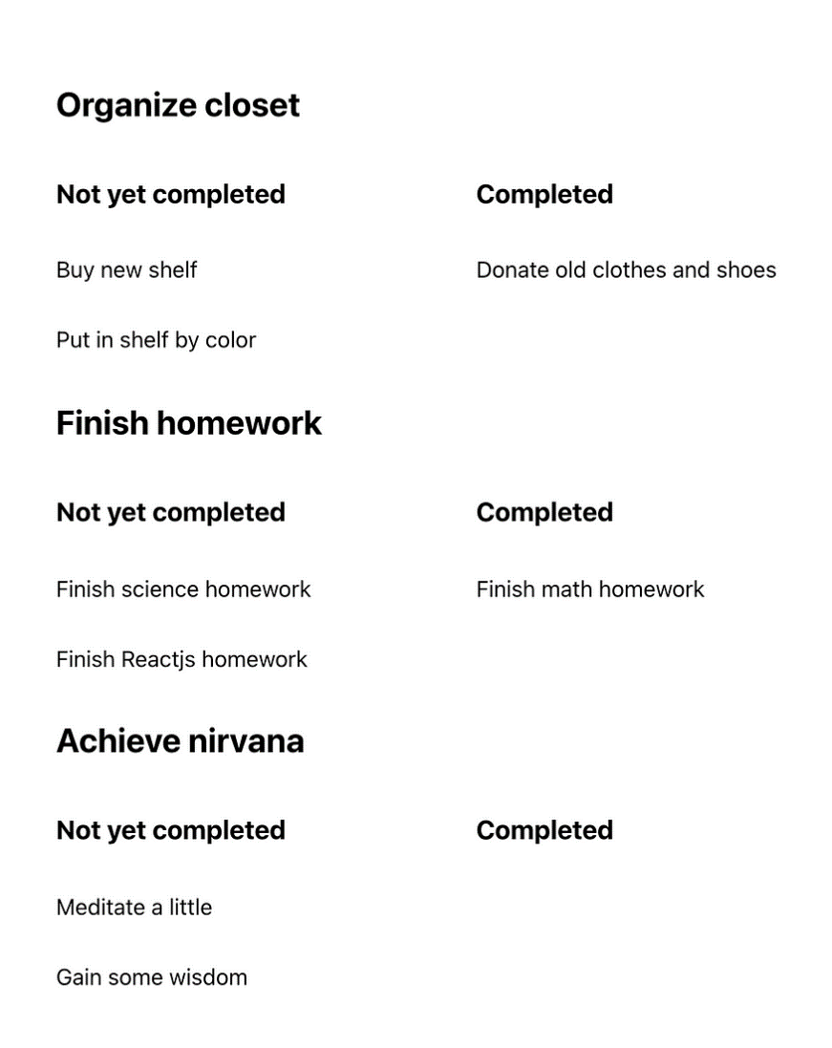

Starter Code (App.js)
Use the environment you are most comfortable with. I recommend using create-react-app to create a local version of the project so that you can inspect easily from your browser when debugging. Alternatively, you can work from a blank React template in CodeSandbox.

CodeSandBox.js

import React, { useState } from 'react';

const INITIAL_LIST = {
"Organize closet": [
{ "Donate old clothes and shoes": false },
{ "Buy new shelf": false },
{ "Put in shelf by color": false },
],
"Finish homework": [
{ "Finish math homework": false },
{ "Finish science homework": false },
{ "Finish Reactjs homework": false },
],
"Achieve nirvana": [
{ "Meditate a little": false },
{ "Gain some wisdom": false },
],
};

function CodeSanBox() {
const [taskList, setTaskList] = useState(INITIAL_LIST);

const toggleSubtask = (task, subtask) => {
const updatedList = { ...taskList };
const subtasks = updatedList[task];

for (let i = 0; i < subtasks.length; i++) {
if (subtasks[i].hasOwnProperty(subtask)) {
subtasks[i][subtask] = !subtasks[i][subtask];
break;
}
}

setTaskList(updatedList);
};

return (
<div>
<h1>Task List</h1>
{Object.entries(taskList).map(([task, subtasks]) => (
<div key={task}>
<h3>{task}</h3>
<div>
<h4>Completed</h4>
<ul>
{subtasks
.filter((subtask) => subtask[Object.keys(subtask)[0]])
.map((subtask, index) => (
<li
key={index}
onClick={() =>
toggleSubtask(task, Object.keys(subtask)[0])
}
>
{Object.keys(subtask)[0]}
</li>
))}
</ul>
</div>
<div>
<h4>To be Completed</h4>
<ul>
{subtasks
.filter((subtask) => !subtask[Object.keys(subtask)[0]])
.map((subtask, index) => (
<li
key={index}
onClick={() =>
toggleSubtask(task, Object.keys(subtask)[0])
}
>
{Object.keys(subtask)[0]}
</li>
))}
</ul>
</div>
</div>
))}
</div>
);
}

export default CodeSanBox;

App.js

import React from 'react';
import CodeSanBox from './component/CodeSandBox';

const App = () => {
return (
<div>
<h1>CodeSanBox Example</h1>
<CodeSanBox />
</div>
);
};

export default App;

- Create a functional component that renders a text input field and displays a list of the strings that the user has entered below it. Each string in the list should be displayed wholly if it has fewer than 6 characters. If not, it should be displayed as the first five characters of the string followed by ellipses. When the user clicks on a string from the list, a modal should popup containing the complete text of the string. The modal should be centered on the page, and it should block the input field. The modal should close when the user clicks outside of it (you should add a border or background to the modal to test that this functionality is included).
The picture below shows the component after the user has entered three strings: “Hi, my name is Justin”, “What is your name?”, and “hello”.
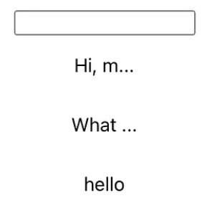
The picture below is the state of the component after the user selects “Hi, m…” from the page above.
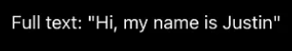
Again, the black square will only disappear and reveal the input field and list when the user clicks outside of it.
Starter Code (App.js)
Use the environment you are most comfortable with. I recommend using create-react-app to create a local version of the project so that you can inspect easily from your browser when debugging. Alternatively, you can work from a blank React template in CodeSandbox.

TextInputField.js

import React, { useState } from 'react';

function TextInputField() {
const [inputValue, setInputValue] = useState('');
const [strings, setStrings] = useState([]);
const [modalOpen, setModalOpen] = useState(false);
const [selectedString, setSelectedString] = useState('');

const handleInputChange = (event) => {
setInputValue(event.target.value);
};

const handleFormSubmit = (event) => {
event.preventDefault();
if (inputValue.trim() !== '') {
setStrings([...strings, inputValue]);
setInputValue('');
}
};

const openModal = (string) => {
setSelectedString(string);
setModalOpen(true);
};

const closeModal = () => {
setModalOpen(false);
};

return (
<div>
<h1>Text Input</h1>
<form onSubmit={handleFormSubmit}>
<input
type="text"
value={inputValue}
onChange={handleInputChange}
/>
<button type="submit">Add</button>
</form>
<ul>
{strings.map((string, index) => (
<li key={index} onClick={() => openModal(string)}>
{string.length <= 5 ? string : `${string.slice(0, 5)}...`}
</li>
))}
</ul>
{modalOpen && (
<div className="modal" onClick={closeModal}>
<div className="modal-content">
<p>{selectedString}</p>
</div>
</div>
)}
</div>
);
}

export default TextInputField;

App.js

import React from 'react';
import TextInputField from './component/TextInputField';

const App = () => {
return (
<div>
<h1>TextInputField Example</h1>
<TextInputField />
</div>
);
};

export default App;

- Create a functional component that accepts as a prop an array of question objects and renders a quiz. The quiz displays one question at a time in the order that they appear in the questions array, and it only advances to the next question when the user selects an answer choice. The quiz does not support returning to previously answered questions, although you can attempt to add this functionality later. After the user has answered all the questions, display the user’s score as a percentage. An example input array is given below, but be sure not to assume that there are a fixed number of questions or that each question has a fixed number of answer choices. The “correct” field of each question object indicates the index of the correct answer choice in the answers array.

Starter Code (App.js)
Use the environment you are most comfortable with. I recommend using create-react-app to create a local version of the project so that you can inspect easily from your browser when debugging. Alternatively, you can work from a blank React template in CodeSandbox.

- Write a functional component that accepts as a prop an array of integers and renders a diagram of mergesort’s divide sequence in action. For those unfamiliar, mergesort is a divide and conquer algorithm that recursively splits an array in half until it has been reduced to arrays of size one. It then works back up the recursive tree, joining the subarrays into sorted order. The algorithm’s worst and best case complexities are both n*log(n). Your component need only display the first phase of the algorithm: the recursive splitting of the array until every segment has reached size one. For example, consider the following array:

const ARRAY = [1, 2, 3, 4, 5, 6, 7, 8, 9, 8, 5, 3, 5, 7, 4, 2];
For the array above, the component should display this page:
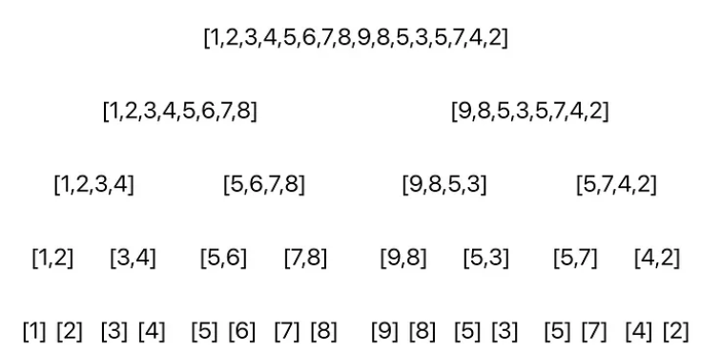
For arrays of an odd size, the right subarray should have one more element than the left subarray after the split.
Up to this point, the challenges have emphasized functionality and generally have not required any styling. This challenge, though, will test your ability to organize containers. Though my solution uses flexbox, feel free to conduct styling however you are most comfortable.
Starter Code (App.js)
Use the environment you are most comfortable with. I recommend using create-react-app to create a local version of the project so that you can inspect easily from your browser when debugging. Alternatively, you can work from a blank React template in CodeSandbox. Keep in mind, though, that the two major facets of this particular challenge are recursion and styling. For the latter, being able to inspect in a browser is crucial.

- Write a functional component that imitates a log-in process. The component should be a form consisting of two input fields — for username and password — and a login button beneath them.
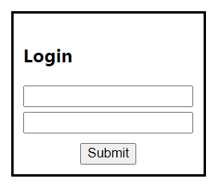
When the user selects Submit or hits enter, the form should check if the username and password entered match some user stored in the component’s state. If so, an alert should appear including the user’s username (as shown below), and the component should reset to its starting state.
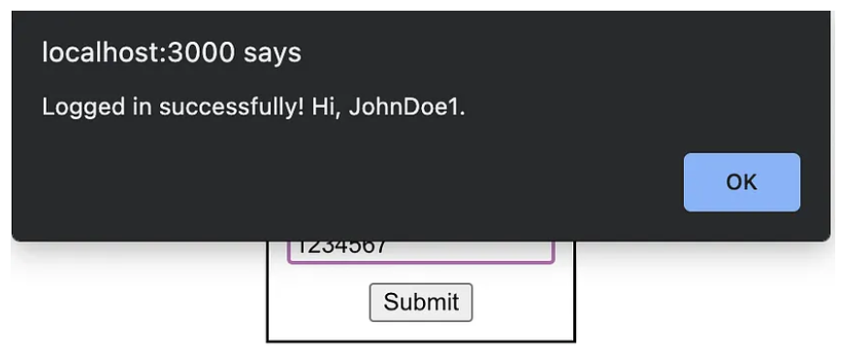
If the username and password entered do not match an existing count, then (so long as each field is more than six characters long) create a new account, store it for future log-ins, and display an alert to notify the user. Just as the form does on successful login, it should clear the input fields following the alert.
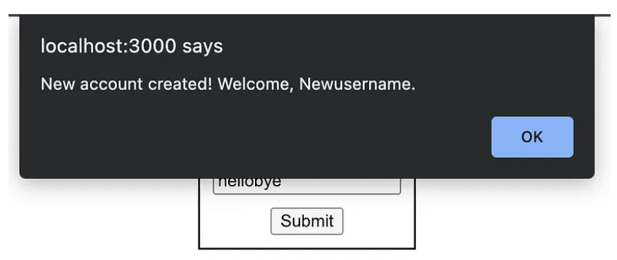
If the username and/or password entered is less than six characters, do not create a new account, and display an alert explaining the issue. Do not clear the input fields so that the user may append to what they have already entered:
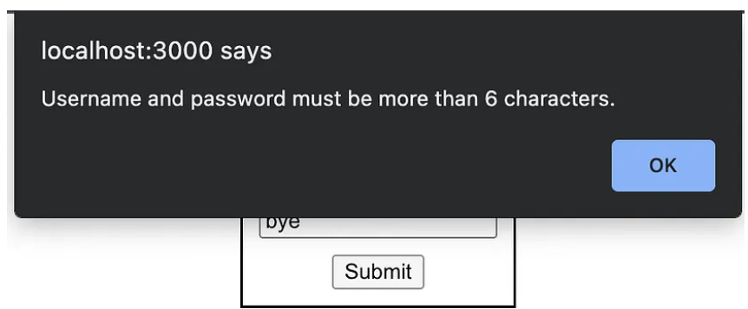
Finally, the user should not be allowed to input more than 20 characters in either field. If the user attempts to add a 21st character to their input, do not reflect their change, and display the error in an alert:
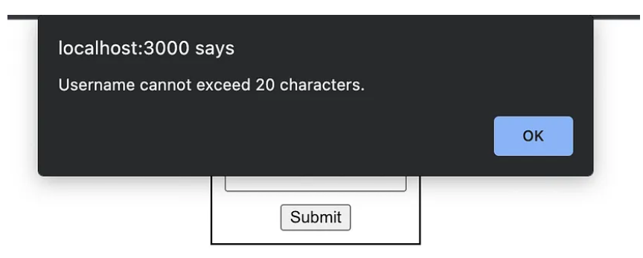
The array in the component’s state that stores existing user objects is prepopulated with one user.

Login.js
import React, { useState } from 'react';

const Login = () => {
const [username, setUsername] = useState('');
const [password, setPassword] = useState('');
const [users, setUsers] = useState([{ username: 'admin', password: 'password' }]);

const handleUsernameChange = (e) => {
setUsername(e.target.value);
};

const handlePasswordChange = (e) => {
setPassword(e.target.value);
};

const handleSubmit = (e) => {
e.preventDefault();

if (username.length < 6 || password.length < 6) {
alert('Username and password must be at least 6 characters long.');
return;
}

const existingUser = users.find((user) => user.username === username && user.password === password);

if (existingUser) {
alert(`Welcome back, ${existingUser.username}!`);
setUsername('');
setPassword('');
} else {
setUsers([...users, { username, password }]);
alert('Account created successfully!');
setUsername('');
setPassword('');
}
};

return (
<div>
<h1>Login</h1>
<form onSubmit={handleSubmit}>
<label>
Username:
<input type="text" value={username} onChange={handleUsernameChange} maxLength={20} />
</label>
<br />
<label>
Password:
<input type="password" value={password} onChange={handlePasswordChange} maxLength={20} />
</label>
<br />
<button type="submit">Submit</button>
</form>
</div>
);
};

export default Login;

App.js
import React from 'react';
import Login from './component/Login';

const App = () => {
return (
<div>
<h1>Login Example</h1>
<Login />
</div>
);
};

export default App;

- Write a functional component that allows a user to enter ratings on the five-star system. The component should initially display five empty stars in a row. When the user hovers over a star, that star as well as all the stars that come before it in the row should become filled (both the empty star and filled star image URLs are provided in the started code below). When the user stops hovering over the star, the component should return to its starting state. Further, if a user clicks on a star, then the component should continue to display that rating even after the user stops hovering; the component should reset only after the user hovers on a star that comes before the clicked star. If the user hovers over later stars, the component should fill those stars but should still display the clicked rating after the hover ends.



- Write a functional component for a button that grows (in height and width) by a constant every second, beginning as soon as the component renders. When the user clicks the button, it should start to instead shrink at the same rate. If they click it again, it should switch back to growing, and so on. The title of the button should reflect this behavior (i.e. it should say “Shrink” if it is currently growing and “Grow” if it currently shrinking). You should also establish minimum and maximum sizes beyond which the button will not shrink or grow, respectively.

Grow.js
import React, { useState, useEffect } from 'react';

const Grow = () => {
const [isGrowing, setIsGrowing] = useState(true);
const [size, setSize] = useState(100);

useEffect(() => {
const timer = setInterval(() => {
if (isGrowing) {
setSize(prevSize => (prevSize < 200 ? prevSize + 10 : prevSize));
} else {
setSize(prevSize => (prevSize > 100 ? prevSize - 10 : prevSize));
}
}, 1000);

return () => clearInterval(timer);
}, [isGrowing]);

const handleButtonClick = () => {
setIsGrowing(prevIsGrowing => !prevIsGrowing);
};

return (
<button
style={{ width: size, height: size }}
onClick={handleButtonClick}
>
{isGrowing ? 'Shrink' : 'Grow'}
</button>
);
};

export default Grow;

App.js
import React from 'react';
import Grow from './component/Grow';

const App = () => {
return (
<div>
<h1>Grow Example</h1>
<Grow />
</div>
);
};

export default App;

- Write a functional component to prompt a user with a CAPTCHA test, or a “Completely Automated Public Turing Test To Tell Computers and Humans Apart”. This component will be a bare-bones version of the tests you have likely encountered online that ask you to check a box, select all images of crosswalks or busses, etc. In the starter code, I have provided URLs for six images (pictures of digits 1–6). Render a button that, when pressed, displays six images and prompts the user to select one of them; the number that the user is asked to select should be generated randomly when the user clicks the button. If the user clicks the correct image, the component should return to its initial state (only a button, closed modal). If they click the wrong image, issue an alert in the browser, but leave the modal open for the user to try again.

CaptchaTest.js
import React, { useState } from 'react';

const CaptchaTest = () => {
const [randomNumber, setRandomNumber] = useState(null);

const generateRandomNumber = () => {
const randomNum = Math.floor(Math.random() * 6) + 1;
setRandomNumber(randomNum);
};

const handleImageClick = (selectedNumber) => {
if (selectedNumber === randomNumber) {
alert('You passed the CAPTCHA test!');
setRandomNumber(null);
} else {
alert('Incorrect selection. Please try again.');
}
};

return (
<div>
<button onClick={generateRandomNumber}>Start CAPTCHA Test</button>
{randomNumber && (
<div>
<p>Please select the image with the number {randomNumber}:</p>
<div>
<img src="image1.jpg" alt="Number 1" onClick={() => handleImageClick(1)} />
<img src="image2.jpg" alt="Number 2" onClick={() => handleImageClick(2)} />
<img src="image3.jpg" alt="Number 3" onClick={() => handleImageClick(3)} />
<img src="image4.jpg" alt="Number 4" onClick={() => handleImageClick(4)} />
<img src="image5.jpg" alt="Number 5" onClick={() => handleImageClick(5)} />
<img src="image6.jpg" alt="Number 6" onClick={() => handleImageClick(6)} />
</div>
</div>
)}
</div>
);
};

export default CaptchaTest;

App.js
import React from 'react';
import CaptchaTest from './component/CaptchaTest';

const App = () => {
return (
<div>
<h1>CaptchaTest Example</h1>
<CaptchaTest />
</div>
);
};

export default App;

- React Application: Component Description
The component provided in the code section below contains two bugs. In its initial state, the component should display five buttons in a row (each of which opens an image) along with a line of text below the buttons that indicates how many of the images are currently open. When the user clicks an image, the image should close and the button should retake its place. The correct starting state is pictured below:
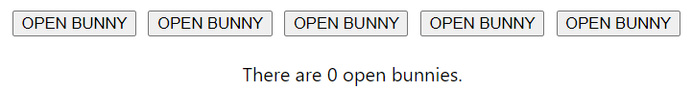
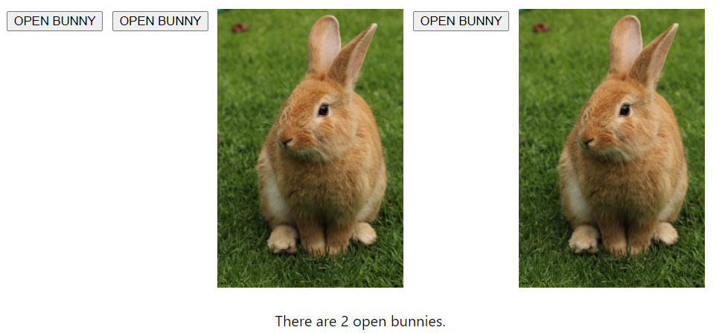

- Write a functional component to display an input field allowing the user to enter a name. When the user submits, the name should be added to a list of names displayed below the input field. Below the list, render two input fields to allow the user to enter two names, and when the user submits, the first name should follow the name. In other words, the second name should be added to the first name’s following and the first name should be added to the second name’s followers. The finished component is shown below:

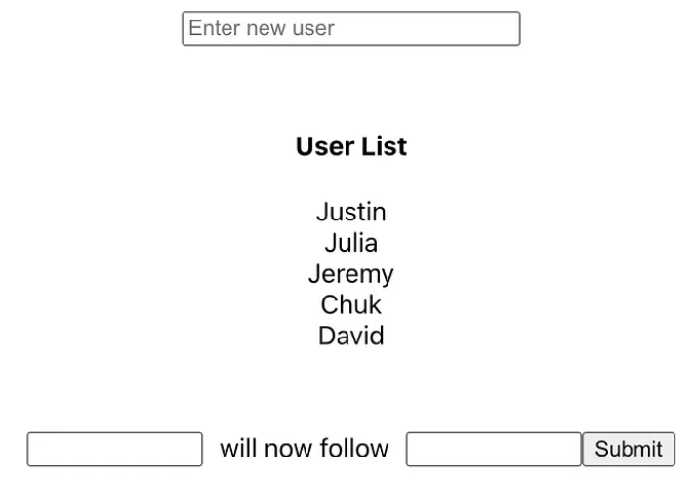

When the user clicks on a name in the list, issue a browser alert that displays their following and followers counts:

FollowerCount.js
import React, { useState } from 'react';

const FollowerCount = () => {
const [name, setName] = useState('');
const [names, setNames] = useState([]);
const [followings, setFollowings] = useState({});
const [followers, setFollowers] = useState({});

const handleNameChange = (event) => {
setName(event.target.value);
};

const handleNameSubmit = (event) => {
event.preventDefault();

if (name.trim() !== '') {
setNames((prevNames) => [...prevNames, name.trim()]);
setFollowings((prevFollowings) => ({ ...prevFollowings, [name.trim()]: [] }));
setFollowers((prevFollowers) => ({ ...prevFollowers, [name.trim()]: [] }));
setName('');
}
};

const handleFollowSubmit = (event) => {
event.preventDefault();

const followerName = event.target.elements.followerName.value.trim();
const followingName = event.target.elements.followingName.value.trim();

if (followerName !== followingName) {
if (!followings[followerName].includes(followingName)) {
setFollowings((prevFollowings) => ({
...prevFollowings,
[followerName]: [...prevFollowings[followerName], followingName],
}));
setFollowers((prevFollowers) => ({
...prevFollowers,
[followingName]: [...prevFollowers[followingName], followerName],
}));
event.target.reset();
} else {
alert(`${followerName} already follows ${followingName}`);
}
} else {
alert("You can't follow yourself");
}
};

const handleNameClick = (clickedName) => {
const followingCount = followings[clickedName].length;
const followerCount = followers[clickedName].length;
alert(`${clickedName} has ${followingCount} following(s) and ${followerCount} follower(s).`);
};

return (
<div>
<form onSubmit={handleNameSubmit}>
<input type="text" value={name} onChange={handleNameChange} placeholder="Enter a name" />
<button type="submit">Add Name</button>
</form>
<ul>
{names.map((name) => (
<li key={name} onClick={() => handleNameClick(name)}>
{name}
</li>
))}
</ul>
<form onSubmit={handleFollowSubmit}>
<input type="text" name="followerName" placeholder="Enter follower's name" />
<input type="text" name="followingName" placeholder="Enter following's name" />
<button type="submit">Follow</button>
</form>
</div>
);
};

export default FollowerCount;

App.js
import React from 'react';
import FollowerCount from './component/FollowerCount';

const App = () => {
return (
<div>
<h1>FollowerCount Example</h1>
<FollowerCount />
</div>
);
};

export default App;

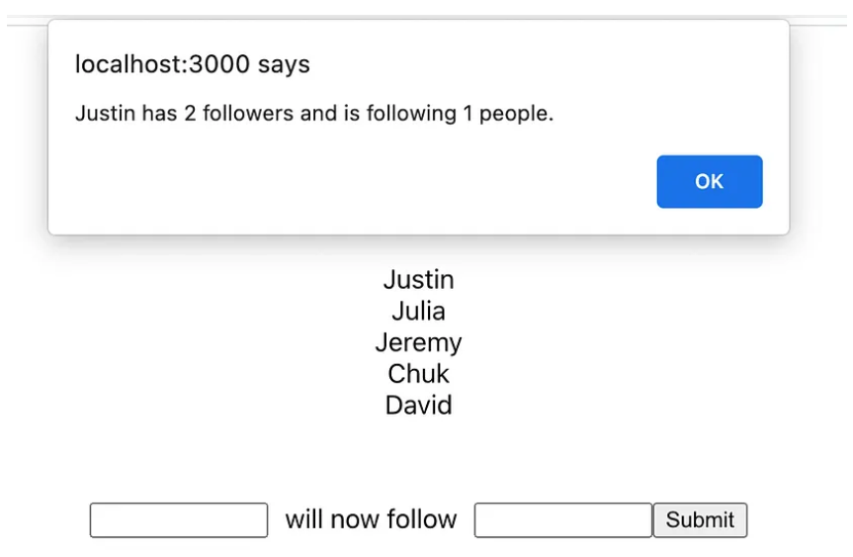
Be sure to handle edge cases, like what to do if the user attempts to make a person follow a person that they already follow, or follow themselves, etc.

- Write a functional component that accepts a list of names as a prop and displays them in a row at the top of the screen. A button should allow the user to toggle between selecting names for team 1 and team 2. When the user clicks on a name in the row, it should be removed from the row and added to the currently selected team. Display two more buttons to randomize the teams and reset the component, respectively. The teams should be displayed under “Team 1” and “Team 2” headings beneath the row and buttons. The finished component after assigning five names to teams is shown below.
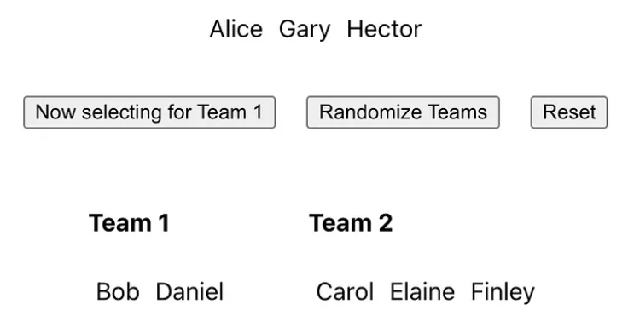
Clicking on “Alice”, “Gary”, or “Hector” in the image above would move them from the row at the top to “Team 1”. To instead assign them to Team 2, the user would click the “Now selecting for Team 1” button to select for Team 2 before clicking the names that they would like to move.

TeamSelector.js
import React, { useState } from 'react';

const TeamSelector = ({ names }) => {
const [team1, setTeam1] = useState([]);
const [team2, setTeam2] = useState([]);
const [selectingTeam1, setSelectingTeam1] = useState(true);

const handleNameClick = (name) => {
if (selectingTeam1) {
setTeam1((prevTeam1) => [...prevTeam1, name]);
} else {
setTeam2((prevTeam2) => [...prevTeam2, name]);
}
};

const handleToggleSelection = () => {
setSelectingTeam1((prevSelectingTeam1) => !prevSelectingTeam1);
};

const handleRandomizeTeams = () => {
const allNames = [...team1, ...team2];
const randomizedNames = shuffleArray(allNames);
const halfLength = Math.ceil(randomizedNames.length / 2);
setTeam1(randomizedNames.slice(0, halfLength));
setTeam2(randomizedNames.slice(halfLength));
};

const handleReset = () => {
setTeam1([]);
setTeam2([]);
setSelectingTeam1(true);
};

const shuffleArray = (array) => {
const newArray = [...array];
for (let i = newArray.length - 1; i > 0; i--) {
const j = Math.floor(Math.random() * (i + 1));
[newArray[i], newArray[j]] = [newArray[j], newArray[i]];
}
return newArray;
};

return (
<div>
<div>
{names.map((name) => (
<button
key={name}
onClick={() => handleNameClick(name)}
disabled={selectingTeam1 ? team1.includes(name) : team2.includes(name)}
>
{name}
</button>
))}
</div>
<div>
<button onClick={handleToggleSelection}>
Now selecting for {selectingTeam1 ? 'Team 1' : 'Team 2'}
</button>
</div>
<div>
<h2>Team 1</h2>
<ul>
{team1.map((name) => (
<li key={name}>{name}</li>
))}
</ul>
<h2>Team 2</h2>
<ul>
{team2.map((name) => (
<li key={name}>{name}</li>
))}
</ul>
</div>
<div>
<button onClick={handleRandomizeTeams}>Randomize Teams</button>
<button onClick={handleReset}>Reset</button>
</div>
</div>
);
};

export default TeamSelector;

App.js
import React from 'react';
import TeamSelector from './component/TeamSelector';

const App = () => {
const names = ['Alice', 'Bob', 'Charlie', 'Gary', 'Hector']; // Replace with your desired list of names

return (
<div>
<h1>Team Selector Example</h1>
<TeamSelector names={names} />
</div>
);
};

export default App;

- Write a functional component that accepts two props — a 4-digit combination and a React component. Your component should display a keypad that allows the user to attempt to enter the 4-digit combination and shows the combination as they enter it above the keypad. If the combination is entered correctly, the site should display the component that is passed to it as a prop (and remove the keypad). The component in its initial state is pictured below:
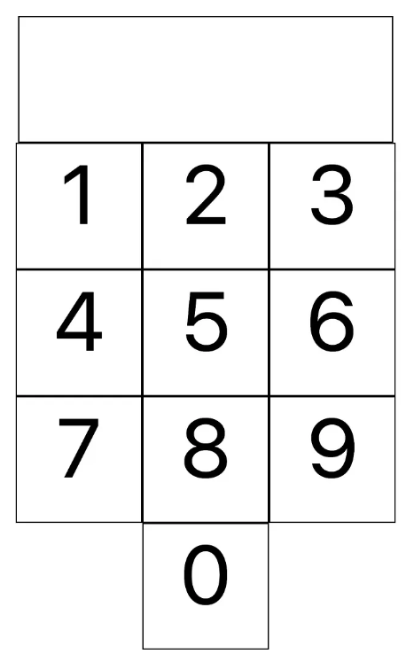
After the users clicks four numbers, if the combination entered does not match the combination passed to the component in the first prop, issue an alert as pictured below and reset the keypad.

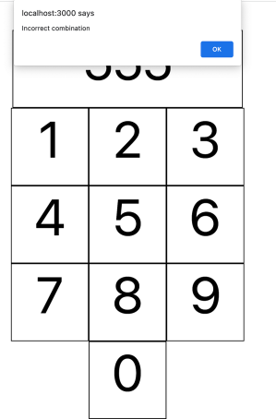
Keypad.js
import React, { useState } from 'react';

const Keypad = ({ combination, component }) => {
const [enteredCombination, setEnteredCombination] = useState('');
const [showComponent, setShowComponent] = useState(false);

const handleNumberClick = (number) => {
setEnteredCombination((prevCombination) => prevCombination + number);
};

const handleResetClick = () => {
setEnteredCombination('');
};

const handleSubmit = (event) => {
event.preventDefault();

if (enteredCombination === combination) {
setShowComponent(true);
} else {
alert('Incorrect combination entered!');
setEnteredCombination('');
}
};

return (
<div>
{!showComponent ? (
<div>
<h2>Enter the 4-digit combination:</h2>
<div>{enteredCombination}</div>
<form onSubmit={handleSubmit}>
<div>
<button type="button" onClick={() => handleNumberClick(1)}>1</button>
<button type="button" onClick={() => handleNumberClick(2)}>2</button>
<button type="button" onClick={() => handleNumberClick(3)}>3</button>
</div>
<div>
<button type="button" onClick={() => handleNumberClick(4)}>4</button>
<button type="button" onClick={() => handleNumberClick(5)}>5</button>
<button type="button" onClick={() => handleNumberClick(6)}>6</button>
</div>
<div>
<button type="button" onClick={() => handleNumberClick(7)}>7</button>
<button type="button" onClick={() => handleNumberClick(8)}>8</button>
<button type="button" onClick={() => handleNumberClick(9)}>9</button>
</div>
<div>
<button type="button" onClick={() => handleNumberClick(0)}>0</button>
<button type="button" onClick={handleResetClick}>Reset</button>
<button type="submit">Submit</button>
</div>
</form>
</div>
) : (
component
)}
</div>
);
};

export default Keypad;

App.js
import React from 'react';
import Keypad from './component/Keypad';

const App = () => {
return (
<div>
<Keypad />
</div>
);
};

export default App;

- In this challenge, we will rely on the API provided by Lorem Picsum, created by David Marby and Nijiko Yonskai. The documentation (including all that you will need for this challenge) can be found on the homepage.
Write a functional component called CustomBlur to render an image from Lorem Picsum. Below it, include a slider that allows the user to adjust the blur effect on the image. If you use the native img element as I do in the solution below, be sure to include a seed in the image so that the image is not replaced as the blur parameter changes.

CustomBlur.js
import React, { useState } from 'react';

const CustomBlur = () => {
const [blurValue, setBlurValue] = useState(0);

const handleBlurChange = (event) => {
setBlurValue(event.target.value);
};

return (
<div>
<img
src={`https://picsum.photos/400/300?blur=${blurValue}&random=${Math.random()}`}
alt="Lorem Picsum"
style={{ filter: `blur(${blurValue}px)` }}
/>
<div>
<label htmlFor="blurRange">Blur:</label>
<input
type="range"
id="blurRange"
min="0"
max="10"
value={blurValue}
onChange={handleBlurChange}
/>
</div>
</div>
);
};

export default CustomBlur;

App.js
import React from 'react';
import CustomBlur from './component/CustomBlur';

const App = () => {
return (
<div>
<CustomBlur />
</div>
);
};

export default App;

- Write a functional component called “Timers” that renders a centered input field and button at the top of the screen, along with a (wrapping) row of countdowns below it. The input field should accept a positive number of seconds from the user, and when the button is pressed, a new timer should be appended to the row and begin counting down from the user-specified number of seconds. When the timer reaches 0, it should be automatically removed from the row. Below is a screen grab of the site after specifying thirty seconds and clicking the “Add Timer” button about 50 times.
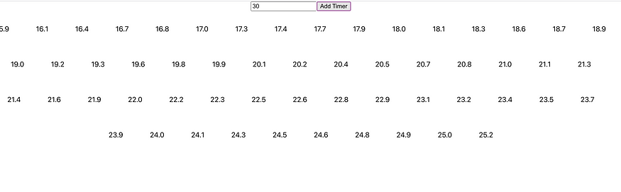
Timers.js
import React, { useState } from 'react';

const Timer = ({ seconds, onTimerComplete }) => {
const [timeLeft, setTimeLeft] = useState(seconds);

// Function to start the countdown
const startCountdown = () => {
const timer = setInterval(() => {
setTimeLeft((prevTime) => {
if (prevTime === 1) {
clearInterval(timer);
onTimerComplete();
}
return prevTime - 1;
});
}, 1000);
};

// Start the countdown when the Timer component is rendered
startCountdown();

return <div>{timeLeft}</div>;
};

const Timers = () => {
const [timers, setTimers] = useState([]);
const [inputValue, setInputValue] = useState('');

const handleInputChange = (event) => {
setInputValue(event.target.value);
};

const handleAddTimer = () => {
const seconds = parseInt(inputValue);
if (!isNaN(seconds) && seconds > 0) {
setTimers((prevTimers) => [...prevTimers, seconds]);
setInputValue('');
}
};

const handleTimerComplete = (index) => {
setTimers((prevTimers) => {
const updatedTimers = [...prevTimers];
updatedTimers.splice(index, 1);
return updatedTimers;
});
};

return (
<div>
<div style={{ textAlign: 'center' }}>
<input
type="number"
min="1"
value={inputValue}
onChange={handleInputChange}
placeholder="Enter seconds"
/>
<button onClick={handleAddTimer}>Add Timer</button>
</div>
<div style={{ display: 'flex', flexWrap: 'wrap', justifyContent: 'center' }}>
{timers.map((seconds, index) => (
<div key={index} style={{ margin: '10px', padding: '10px', border: '1px solid black' }}>
<Timer seconds={seconds} onTimerComplete={() => handleTimerComplete(index)} />
</div>
))}
</div>
</div>
);
};

export default Timers;

App.js
import React from 'react';
import Timers from './component/Timers';

const App = () => {
return (
<div>
<Timers />
</div>
);
};

export default App;

- Creating a simple counter component that increments a number every time a button is clicked. (useState hook to be used)
Expectations:
- Every time the button is clicked, the number should increment by 1.
- Display the current number state in the text element.
Answer: 48

- Controlled Input Field - Create an input field component that allows a user to type in text and displays the text in real-time.
- Every time the user types something in the input field, the text should update in the text element
- You should use the useState hook to keep track of the text state.
InputField.js
import React, { useState } from 'react';

const InputField = () => {
const [text, setText] = useState('');

const handleTextChange = (event) => {
setText(event.target.value);
};

return (
<div>
<h2>Controlled Input Field</h2>
<input type="text" value={text} onChange={handleTextChange} />
<p>Text: {text}</p>
</div>
);
};

export default InputField;

App.js
import React from 'react';
import InputField from './component/InputField';

const App = () => {
return (
<div>
<InputField />
</div>
);
};

export default App;

- Toggle Visibility - You're tasked with creating a component that toggles the visibility of a piece of text when a button is clicked. Expectations:
- Initially, the text should be hidden.
- When the button is clicked, the text should become visible if it was hidden, and hidden if it was visible.
- Use the useState hook to manage the visibility state.
ToggleVisibility.js
import React, { useState } from 'react';

const ToggleVisibility = () => {
const [isVisible, setIsVisible] = useState(false);

const handleToggleVisibility = () => {
setIsVisible(!isVisible);
};

return (
<div>
<h2>Toggle Visibility</h2>
<button onClick={handleToggleVisibility}>
{isVisible ? 'Hide Text' : 'Show Text'}
</button>
{isVisible && <p>This text is now visible!</p>}
</div>
);
};

export default ToggleVisibility;

App.js
import React from 'react';
import ToggleVisibility from './component/ToggleVisibility';

const App = () => {
return (
<div>
<ToggleVisibility />
</div>
);
};

export default App;

- Character Counter: Create a simple Character Counter component that allows users to type in text and displays the number of characters in real-time.
Expectations:
- Create a textarea element for users to type in text
- Display the character count below the textarea in real-time
- Use the useState hook to manage the text state.
CharacterCounter.js
import React, { useState } from 'react';

const CharacterCounter = () => {
const [text, setText] = useState('');

const handleTextChange = (event) => {
setText(event.target.value);
};

return (
<div>
<h2>Character Counter</h2>
<textarea value={text} onChange={handleTextChange} />
<p>Character count: {text.length}</p>
</div>
);
};

export default CharacterCounter;

App.js
import React from 'react';
import CharacterCounter from './component/CharacterCounter';

const App = () => {
return (
<div>
<CharacterCounter />
</div>
);
};

export default App;

- Todo List: You are tasked with creating a simple Todo List component that allows users to add new items to the list and delete items once they are completed. The Todo List should have the following features:
- An input field for adding new todo items
- A button to submit the new todo item
- Display the list of todo items
- A delete button next to each todo item to remove it from the list
- Use the useState hook to manage the todo list state.
TodoList.js
import React, { useState } from 'react';

const TodoList = () => {
const [todoList, setTodoList] = useState([]);
const [newTodo, setNewTodo] = useState('');

const handleInputChange = (event) => {
setNewTodo(event.target.value);
};

const handleAddTodo = () => {
if (newTodo.trim() !== '') {
setTodoList([...todoList, newTodo]);
setNewTodo('');
}
};

const handleDeleteTodo = (index) => {
const updatedList = [...todoList];
updatedList.splice(index, 1);
setTodoList(updatedList);
};

return (
<div>
<h2>Todo List</h2>
<div>
<input
type="text"
value={newTodo}
onChange={handleInputChange}
placeholder="Add a new todo item"
/>
<button onClick={handleAddTodo}>Add</button>
</div>
<ul>
{todoList.map((todo, index) => (
<li key={index}>
{todo}
<button onClick={() => handleDeleteTodo(index)}>Delete</button>
</li>
))}
</ul>
</div>
);
};

export default TodoList;

App.js
import React from 'react';
import TodoList from './component/TodoList';

const App = () => {
return (
<div>
<TodoList/>
</div>
);
};

export default App;

- Color Switcher: In this exercise, you are tasked with creating a simple Color Switcher component that allows users to change the background color of a div by selecting a color from a dropdown list.
Expectations:
- Create a dropdown list with a few color options (e.g., red, blue, green, yellow)
- When a color is selected from the dropdown, the background color of the div should change to the selected color
- Use the useState hook to manage the background color state.
ColorSwitcher.js
import React, { useState } from 'react';

const ColorSwitcher = () => {
const [backgroundColor, setBackgroundColor] = useState('');

const handleColorChange = (event) => {
setBackgroundColor(event.target.value);
};

return (
<div>
<h2>Color Switcher</h2>
<select value={backgroundColor} onChange={handleColorChange}>
<option value="">Select a color</option>
<option value="red">Red</option>
<option value="blue">Blue</option>
<option value="green">Green</option>
<option value="yellow">Yellow</option>
</select>
<div
style={{
width: '200px',
height: '200px',
backgroundColor: backgroundColor,
}}
></div>
</div>
);
};

export default ColorSwitcher;

App.js
import React from 'react';
import ColorSwitcher from './component/ColorSwitcher';

const App = () => {
return (
<div>
<h1>Color Switcher Example</h1>
<ColorSwitcher />
</div>
);
};

export default App;

- Search Filter: You are tasked with creating a simple Search Filter component that allows users to filter a list of items based on their search input.
Expectations:
- Create an input field for users to type in their search query
- Display the list of items and filter them based on the user's search input
- Use the useState hook to manage the search input state.
SearchFilter.js
import React, { useState } from 'react';

const SearchFilter = () => {
const [searchQuery, setSearchQuery] = useState('');
const [filteredItems, setFilteredItems] = useState([
'Item 1',
'Item 2',
'Item 3',
'Item 4',
'Item 5',
]);

const handleInputChange = (event) => {
setSearchQuery(event.target.value);
filterItems(event.target.value);
};

const filterItems = (query) => {
const filtered = filteredItems.filter((item) =>
item.toLowerCase().includes(query.toLowerCase())
);
setFilteredItems(filtered);
};

return (
<div>
<h2>Search Filter</h2>
<input
type="text"
placeholder="Search..."
value={searchQuery}
onChange={handleInputChange}
/>
<ul>
{filteredItems.map((item, index) => (
<li key={index}>{item}</li>
))}
</ul>
</div>
);
};

export default SearchFilter;

App.js
import React from "react";
import SearchFilter from "./component/SearchFilter";

const App = () => {
return (
<div>
<h1>Search Filter Example</h1>
<SearchFilter />
</div>
);
};

export default App;

- Drag and Drop List: You are tasked with creating a simple Drag and Drop List component that allows users to reorder a list of items by dragging and dropping them. The Drag and Drop List should have the following features:
- Display the list of items
- Allow users to drag and drop items to reorder the list
- Use the useState hook to manage the list state
DragAndDrop.js
import React, { useState } from 'react';

const DragAndDropList = () => {
const [list, setList] = useState([
'Item 1',
'Item 2',
'Item 3',
'Item 4',
'Item 5',
]);

const handleDragStart = (event, index) => {
event.dataTransfer.setData('text/plain', index);
};

const handleDragOver = (event) => {
event.preventDefault();
};

const handleDrop = (event, targetIndex) => {
const sourceIndex = event.dataTransfer.getData('text/plain');
const newList = [...list];
const [removed] = newList.splice(sourceIndex, 1);
newList.splice(targetIndex, 0, removed);
setList(newList);
};

return (
<div>
<h2>Drag and Drop List</h2>
<ul>
{list.map((item, index) => (
<li
key={index}
draggable
onDragStart={(event) => handleDragStart(event, index)}
onDragOver={handleDragOver}
onDrop={(event) => handleDrop(event, index)}
>
{item}
</li>
))}
</ul>
</div>
);
};

export default DragAndDropList;

App.js
import React from 'react';
import DragAndDropList from './DragAndDropList';

const App = () => {
return (
<div>
<h1>Drag and Drop List Example</h1>
<DragAndDropList />
</div>
);
};

export default App;

- Build a simple counter component using the useState Hook. The counter component will display a count value and two buttons: one to increment the count and one to decrement the count.
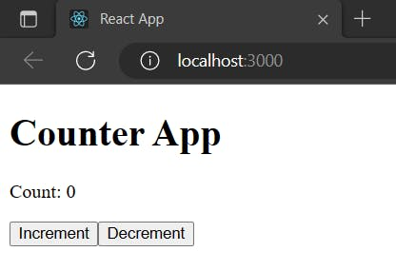
Counter.js
import React, { useState } from 'react';

const Counter = () => {
const [count, setCount] = useState(0);

const increment = () => {
setCount(count + 1);
};

const decrement = () => {
setCount(count - 1);
};

return (
<div>
<h2>Count: {count}</h2>
<button onClick={increment}>Increment</button>
<button onClick={decrement}>Decrement</button>
</div>
);
};

export default Counter;

App.js
import React from 'react';
import Counter from './Counter';

const App = () => {
return (
<div>
<h1>Simple Counter</h1>
<Counter />
</div>
);
};

export default App;

- Multi-Page navigation using React Router: React code to develop a multipage application with navigation for Home, About and Blog pages. The route-based component rendering is implemented using the “react-dom” npm package to allow users to navigate to different pages and render the component with respect to the route.
The following are the steps to Navigation with React Router in React JS:
- Add “react-router-dom” npm package to package.json .
- Specify the path for every component.
- Enclose the routes with <Router> and <Route> in App.js.

- MongoDB
Insert the following documents into a movies collection.
title : Fight Club
writer : Chuck Palahniuk
year : 1999
actors : [
Brad Pitt
Edward Norton
]

title : Pulp Fiction
writer : Quentin Tarantino
year : 1994
actors : [
John Travolta
Uma Thurman
]

title : Inglorious Basterds
writer : Quentin Tarantino
year : 2009
actors : [
Brad Pitt
Diane Kruger
Eli Roth
]

title : The Hobbit: An Unexpected Journey
writer : J.R.R. Tolkein
year : 2012
franchise : The Hobbit

title : The Hobbit: The Desolation of Smaug
writer : J.R.R. Tolkein
year : 2013
franchise : The Hobbit

title : The Hobbit: The Battle of the Five Armies
writer : J.R.R. Tolkein
year : 2012
franchise : The Hobbit
synopsis : Bilbo and Company are forced to engage in a war against an array of combatants and keep the Lonely Mountain from falling into the hands of a rising darkness.

title : Pee Wee Herman's Big Adventure

title : Avatar
query the movies collection to
insertion:
db.movies.insertMany([
{
title: "Fight Club",
writer: "Chuck Palahniuk",
year: 1999,
actors: ["Brad Pitt", "Edward Norton"]
},
{
title: "Pulp Fiction",
writer: "Quentin Tarantino",
year: 1994,
actors: ["John Travolta", "Uma Thurman"]
},
{
title: "Inglorious Basterds",
writer: "Quentin Tarantino",
year: 2009,
actors: ["Brad Pitt", "Diane Kruger", "Eli Roth"]
},
{
title: "The Hobbit: An Unexpected Journey",
writer: "J.R.R. Tolkein",
year: 2012,
franchise: "The Hobbit"
},
{
title: "The Hobbit: The Desolation of Smaug",
writer: "J.R.R. Tolkein",
year: 2013,
franchise: "The Hobbit"
},
{
title: "The Hobbit: The Battle of the Five Armies",
writer: "J.R.R. Tolkein",
year: 2012,
franchise: "The Hobbit",
synopsis: "Bilbo and Company are forced to engage in a war against an array of combatants and keep the Lonely Mountain from falling into the hands of a rising darkness."
},
{
title: "Pee Wee Herman's Big Adventure"
},
{
title: "Avatar"
}
]);

- get all documents
db.movies.find({})
- get all documents with writer set to "Quentin Tarantino"
db.movies.find({ writer: "Quentin Tarantino" })
- get all documents where actors include "Brad Pitt"
db.movies.find({ actors: "Brad Pitt" })
- get all documents with franchise set to "The Hobbit"
db.movies.find({ franchise: "The Hobbit" })
- get all movies released in the 90s
db.movies.find({ year: { $gte: 1990, $lte: 1999 } })
- get all movies released before the year 2000 or after 2010
db.movies.find({ $or: [{ year: { $lt: 2000 } }, { year: { $gt: 2010 } }] })

- MongoDB
Insert the documents into a movies collection.
Update Documents
- add a synopsis to "The Hobbit: An Unexpected Journey" : "A reluctant hobbit, Bilbo Baggins, sets out to the Lonely Mountain with a spirited group of dwarves to reclaim their mountain home - and the gold within it - from the dragon Smaug."
- add a synopsis to "The Hobbit: The Desolation of Smaug" : "The dwarves, along with Bilbo Baggins and Gandalf the Grey, continue their quest to reclaim Erebor, their homeland, from Smaug. Bilbo Baggins is in possession of a mysterious and magical ring."
- add an actor named "Samuel L. Jackson" to the movie "Pulp Fiction".

Insert many
db.movies.insertMany([
{
title: "The Hobbit: An Unexpected Journey",
synopsis: "A reluctant hobbit, Bilbo Baggins, sets out to the Lonely Mountain with a spirited group of dwarves to reclaim their mountain home - and the gold within it - from the dragon Smaug."
},
{
title: "The Hobbit: The Desolation of Smaug",
synopsis: "The dwarves, along with Bilbo Baggins and Gandalf the Grey, continue their quest to reclaim Erebor, their homeland, from Smaug. Bilbo Baggins is in possession of a mysterious and magical ring."
},
{
title: "Pulp Fiction",
synopsis: "The lives of two mob hitmen, a boxer, a gangster's wife, and a pair of diner bandits intertwine in four tales of violence and redemption."
}
]);

Query the following,
- find all movies that have a synopsis that contains the word "Bilbo"
db.movies.find({ synopsis: { $regex: "Bilbo", $options: "i" } })
- find all movies that have a synopsis that contains the word "Gandalf"
db.movies.find({ synopsis: { $regex: "Gandalf", $options: "i" } })
- find all movies that have a synopsis that contains the word "Bilbo" and not the word "Gandalf"
db.movies.find({ synopsis: { $regex: "Bilbo", $options: "i" }, synopsis: { $not: /Gandalf/i } })
- find all movies that have a synopsis that contains the word "dwarves" or "hobbit"
db.movies.find({ $or: [{ synopsis: { $regex: "dwarves", $options: "i" } }, { synopsis: { $regex: "hobbit", $options: "i" } }] })
- find all movies that have a synopsis that contains the word "gold" and "dragon"
db.movies.find({ synopsis: { $regex: "gold", $options: "i" }, synopsis: { $regex: "dragon", $options: "i" } })

